MEDITERRANEAN ACTION PLAN (MAP)
REGIONAL MARINE POLLUTION EMERGENCY RESPONSE CENTRE FOR THE MEDITERRANEAN SEA (REMPEC)

QUESTIONS AND ANSWERS
RELATED TO CALL FOR QUOTATION FOR THE PROVISION OF IT SERVICES FOR THE DEVELOPMENT OF THE MARITIME INTEGRATED DECISION SUPPORT INFORMATION SYSTEM ON TRANSPORT OF CHEMICAL SUBSTANCES (MIDSIS-TROCS 4.0)

Question 1: Once the delivery of MIDSIS-TROCS 4.0 has been completed will you require on-going support and maintenance services as is currently provided for the West MOPoCo Website?
Answer 1: The consultant is invited to include in his/her technical and financial offer this option.
********
Question 2: Can we have a schema of the current database?
Answer 2: Below extracts related to the schema of the current database
Database schemas and structure

The information in MIDSIS-TROCS database will be structure using the following tables:

- Chemical products table: this table will include all the chemical and physical data related to the chemical products of interest. The particular fields of this database will be validated by the HNS expert and approved by REMPEC. It is expected that this database will include most of the data already in version 2.0 of the application. However, some fields might have to be modified as a result of the update of data. In particular, it will contain the following information items:
- Physical and Chemical Data.
- Transportation Data.
- Reactivity Data.
- GESAMP Data; and
- Marine Pollution Data.

- Synonym table: this table will include the synonyms of each chemical product in both French and English and will be related to the chemical products table using a unique identifier for every chemical product.

- Expert table: this table will contain all the relevant information about the expert in relation with particular chemical product. As an example, it will contain the name, email address and phone number of the expert. However, it is possible that this table is replaced by links to specific URLs if specified by REMPEC.

The idea is to link the information from the different tables using a unique identifier that will be assigned to each chemical product. Figure 4 represents the schemas of the database tables.

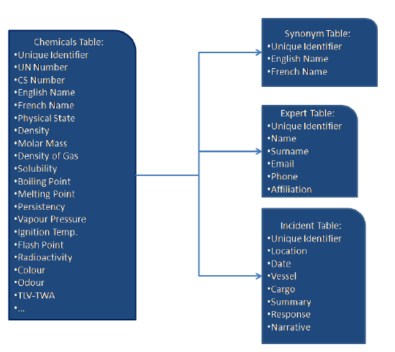
Schemas of the database tables
********
Question 3: Is it required to develop a map with all the accidents? If yes, what are the interactions with the other data?
Answer 3: It is required to develop a map with all the accidents. Expected interactions are with the incidents sheets as well as the chemical substances.
********
Question 4: On what operating systems (desktop and mobile) should the stand-alone application you mention as Package 2 work on?
Answer 4: The stand-alone application should run on the latest available versions of the following operating systems; Windows and Mac OS for desktop and iOS and Android for mobile phones.
********
Question 5: We noticed that currently stand-alone application (Package 2) is a Tomcat application. Is it an exact copy of the online environment? Considering that the new application will be developed with Plone 5, could the desktop/computer version be a Plone 5 instance to install on the client machine?
Answer 5: The Tomcat application was developed to be the exact copy of the online environment. It is expected that the new application developed under this activity be based on the website developed on Plone 5. Therefore, the desktop/computer version could also be developed on Plone5.
********
Question 6: Can the mobile stand-alone version (Package 2) be developed as a hybrid application or must it be a native application? Must it be made available on your accounts at the official stores (iTunes, Google Play Store, ...)?
Answer 6: Please include in your offer the options of developing the stand-alone application as hybrid application or native application, as well as the respective advantages and disadvantages. The stand-alone application should be accessible on official stores (iTunes, Google Play Store, ...).
********
Question 7: Will the update of data in the stand-alone application (Package 2) be executed automatically or can be executed manually by the user after receiving an update notification?

Answer 7: The update of data in the stand-alone application should be automatically excecuted once the website is updated without any manual intervention by the user.
********
Question 8: Must even the maps be made available in the stand-alone application (Package 2) without a connection?

Answer 8: Yes the maps should be made available in the stand-alone application without a connection.
********
Question 9: Does all data must be available in the stand-alone application (Package 2) or only some of them? Can you indicate which one?

Answer 9: All data available on the website should be found on the stand-alone application.

********

